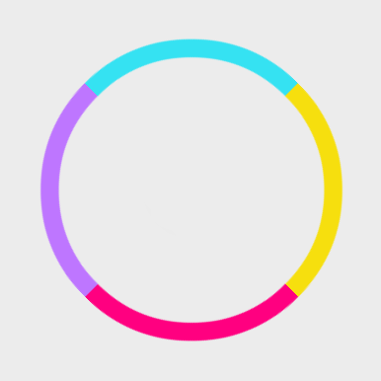

**GAME DOCUMENTATION**

**Contents**

**OVERVIEW** 3

BASIC FEATURES 3

**UPDATE HISTORY** 4

**SETTING UP THE PROJECT** 5

IMPORTING INTO UNITY 5

SETTING UP THE GAME 5

**ADMOB INTEGRATION** 8

**PLAY GAMES LEADERBOARD INTEGRATION** 9

**CONTACTS** 11

USEFUL INFORMATION 11

**OVERVIEW**

Thank you for purchasing the Crazy Wheel game template. This is a full Unity template that gives you a quick and easy way to create a simple tap to match arcade game or as starting base to learn Unity and C# programming. The game features a modern flat UI with some beautiful animated menu.

## BASIC FEATURES

* Ready to publish, web, desktop and mobile optimized.
* 100% commented C# code with editor tips.
* New Unity's UI with some beautiful animated menus.
* Responsive design. Looks good on all platforms.
* Simple sound effects.
* Simple score system
* And so much more

This documentation is constantly updated together with the template. Ensure you have the latest version.

**NOTE: ALWAYS BACK-UP YOUR WORK BEFORE UPDATING TO A NEWER VERSION.**

I will also be adding new features over time and extend this template’s capabilities. Send me your suggestions via email.

**UPDATE HISTORY**

**Version 1.0**

* Initial release.

**Version 1.1**

* Ability to set the initial and maximum speed for each level.

**Version 1.2**

* Added Admob Banner Ads (iOS/Android)
* General UI tweaks.

**Version 1.3**

* Added Admob Interstitial Ads (iOS/Android)
* Added Google Play Leaderboards (Android)
* Streamlined Ads and Leaderboard integration.

**SETTING UP THE PROJECT**

## IMPORTING INTO UNITY

This template is designed to be used as a starter kit and I recommending importing it as a new project.

Create a new 2D project and import this template.

You should see all the folders mentioned above in your Unity project.

## SETTING UP THE GAME

Throughout this template, you will be dealing with 3 major areas: **The game controller, the circles and the dial.** Let us look on how to set up each one of them.

The Game Controller

The Game Controller is the core component. We will use it to disable/enable various gameobjects, update scores, the colors etc.

**The canvases –** This are the UI display screens for various parts of the game. We will enable and disable some of the canvases during different times of the game. Make sure you drag the correct canvas to the correct slot.

**The Dial Speeds –** The initial speed for each difficulty level. (Easy, Medium and Hard)

**Color List –** A list of all the colors used in the game.

**Difficulty Buttons –** The easy, medium and hard button used to set the difficulty level.

**Circles –** The various circles for each level.

**Score Text –** The player’s current score. We update this has he/she progresses in the game.

**Final Score Text –** The player’s final score after losing.

**Highscore Text –** The player’s highscore for that particular level.

**Sound Button –** The sound button.

**Sound Graphic –** The images we should display on the sound button when the game sound is on/off.

**Game Links -** The link to your games store listing where the game users can rate your game and make it famous. ☺

**Dial Sounds** **–** The various sounds we will play in the game.

The Circles

Each circles is made up for smaller segments. See below. Each segments has a polygon 2D collider attached, a rigidbody and a CircleBlock script.

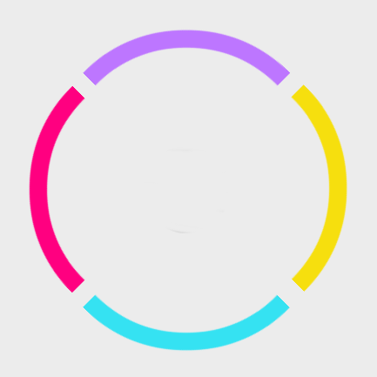 

Fig. **Circle Segments**

Each segments needs to be allocated a color index that will be assigned from the game controller during runtime. This number should be constant and **EACH SEGMENT MUST HAVE ITS OWN UNIQUE COLOR INDEX (RANGE IS 0-5)**

**NOTE:** You need to define a new tag ‘Block’ on the editor and assign it to all the circle quarters for each circle.

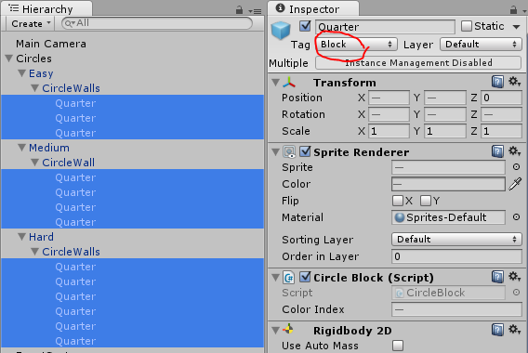

The Dial

The dial is a simple 2D sprite. We will apply some force to this from the script and make it move in a circular motion just like in an analog clock.

The dial consists of an extended box 2D collider, rigidbody and the dial controller script.

**Instruct Text –** The instructions text gameobject.

**Max Speeds –** The maximum speed for the dial for each difficulty level.

**Speed Increase –** The amount of speed to add to the initial speed for every correct color.

**Clockwise –** Is the dial moving clockwise or anticlockwise?

Once all that is done, the game is ready to be shipped. Just build and publish.

If you need to modify the game code, feel free to. The entire code base is well commented and shouldn’t be a problem to modify.

**TIP –** Hover the mouse on different texts to see tips.

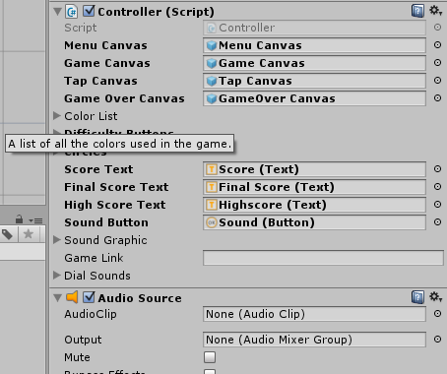

Fig. **Game Controller Tips**

**ADMOB INTEGRATION**

1. Download the unity package from [here](https://github.com/googleads/googleads-mobile-unity/releases).
2. Setup the ad IDS [here](https://www.google.com/admob/) (One banner + One Interstitial)
3. Make sure the project is set to either ***Android*** or ***iOS***.
4. Import the package you downloaded in step 1 above.
5. On the Unity Editor, Go to **Tools > Mintonne > Configuration > Configure Admob*.***
6. On the AdManager gameobject, you should see the banner and interstitial input fields.

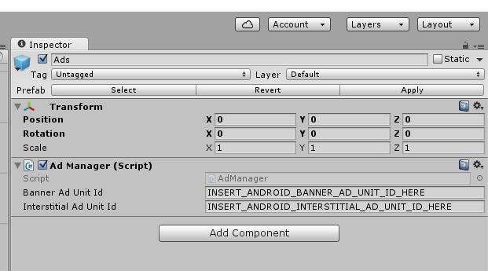

1. Enter the ad IDS from the admob dashboard.
2. Build game.
3. After the game is published on the store, don’t forget to link the game on the Admob dashboard.

**PLAY GAMES LEADERBOARD INTEGRATION**

1. Download the Play Games plugin [here](https://github.com/playgameservices/play-games-plugin-for-unity).
2. Carefully follow the instructions on [this page](https://github.com/playgameservices/play-games-plugin-for-unity) on how to setup the plugin on the editor and how to create leaderboards on the Google Play Developer Console.

**NB:**

* **Create 3 different leaderboards for each difficulty level.**
* **In order to publish the play games leaderboard, Google requires you have at least 5 achievements. Add 5 random achievements (We will not use this but Google policies require that they are there.)**

1. On the Unity Editor, Go to **Tools > Mintonne > Configuration > Configure Leaderboards*.***
2. On the LeaderboardMaanager gameobject, you should see the leaderboard input fields.

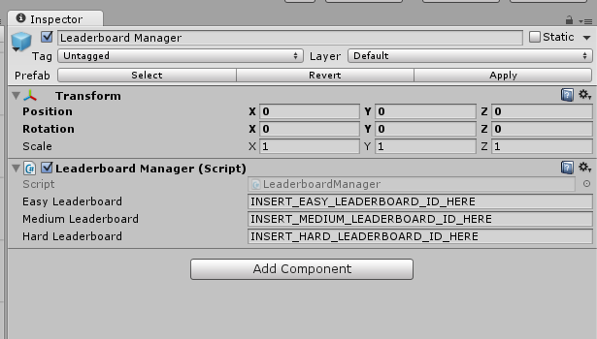

1. Enter the ad IDS from the Developer Console.
2. On your leaderboard button on the UI, add a new OnClick event, drag the leaderboard manager gameobject to the ***object*** field and select the ‘ShowLeaderboard’ function on the list.

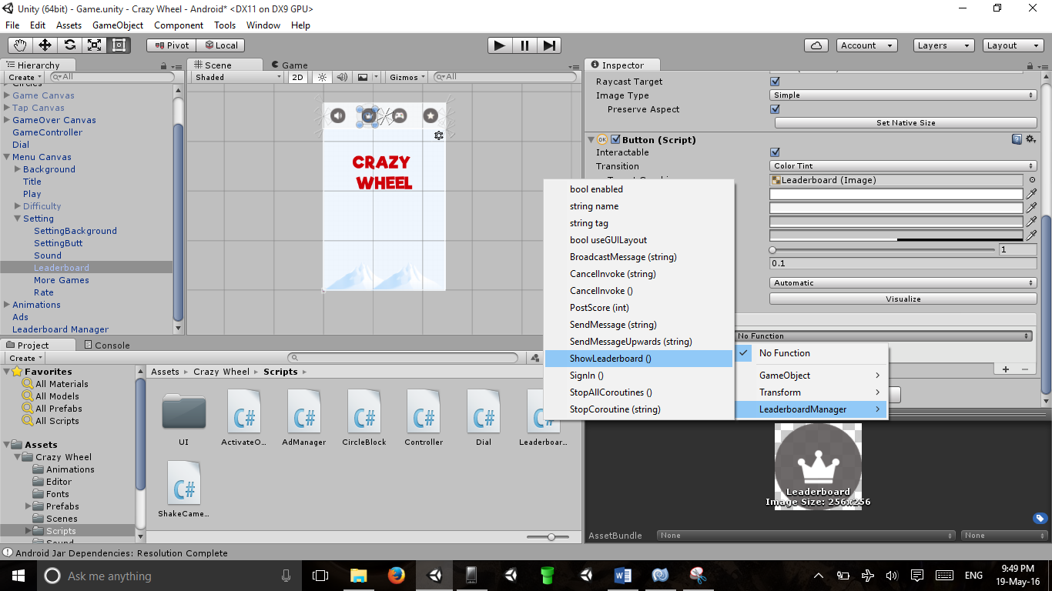

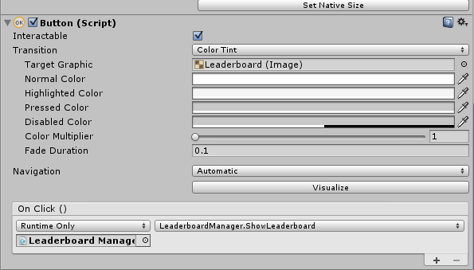

1. Build game.
2. After you have uploaded the APK, link the game on the Play Games Console section. At

**CONTACTS**

A bug? Error? Or you just can’t find something. You can always reach me via email at Mintonne@gmail.com and I will get back to you as soon as possible.

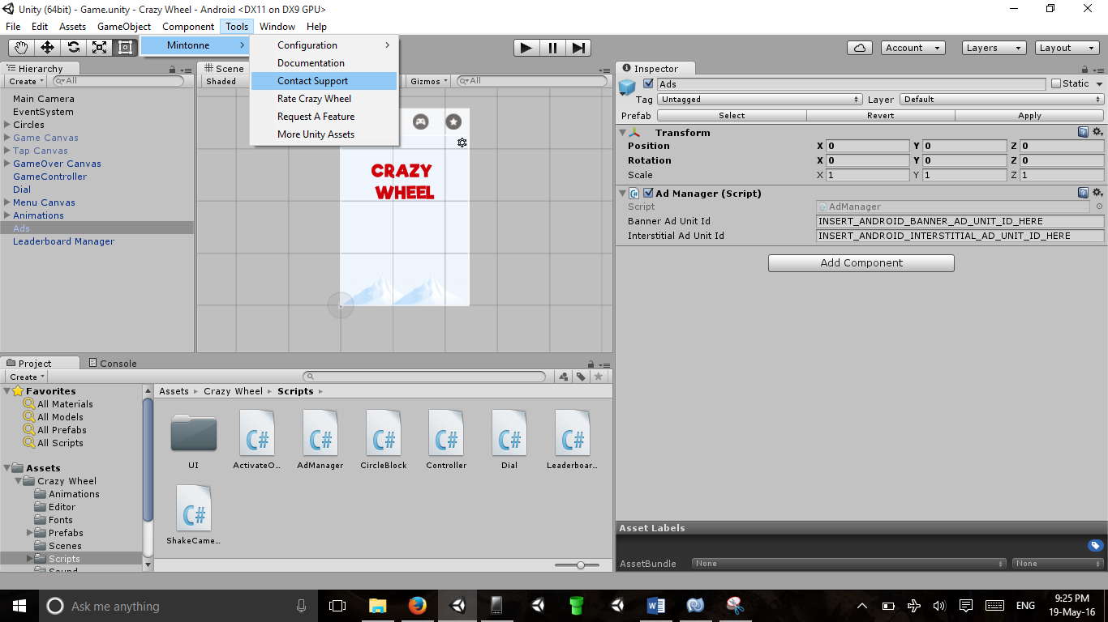

**Unity Editor Shortcuts**

## USEFUL INFORMATION

Time zone – GMT +3

Twitter - [@MintonneX](http://www.twitter.com/mintonnex)